**M I C H E L L E A J W A N I**

**D I G I T A L M A R K E T I N G**

# ABOUT ME

**A hard working and dedicated Digital Marketer creafing content to contribute to our growing digital culture.**

**Passionate about creafing innovafive designs which are digitally driven to a5ract consumers everyday.**

# EXPERIENCE

**July -December 2018**

**July -August 2017**

**Digital Markefing Contractor at Titan Mutual Lending**

**Irvine, California, USA Community Outreach**

**Prayatna- For people with special needs**

# MICHELLE AJWANI

*ms¢helleŒ¡vŒns@gmŒsl.¢om vvv.behŒn¢e.net/ms¢helleŒ¡1ßŒ8*

**August-December 2017**

**Teach for India**

*ms¢helleŒ¡vŒnsSblog.voTdpTeSS.¢om*

**May-July 2016**

# EDUCATION

**2016-2020**

# COURSES

**Retail Job at the Irvine Spectrum Center The Children’s Place, Irvine, Califronia, USA**

**Bachelor of Arts (B.A) in Liberal Arts**

**Symbiosis School for Liberal Arts**

**Symbiosis Internafional (Deemed) University**

**Major- Media Studies Minor-Business Studies (A)**

*+9198SSßß991F*

*lsnkedsn.¢om/sn/ms¢helle-Œ¡vŒns-03S8Œ3163*

# SKILLS AND PROFICIENCY

**Social Media Markefing Web Design**

**Digital Markefing Planning**

**April 2020 Dissertafion- The Infuence of Logos on**

**Consumers in the Fast Food Indsustry Capstone Project-Food Blog**

**Adobe Photoshop**

**March 2020**

**Seminar Paper-The Impact of Social Media**

**Markefing on Existenfial Ethics**

**Email Markefing**

**October 2019 Fundamentals of Digital Markefing -**

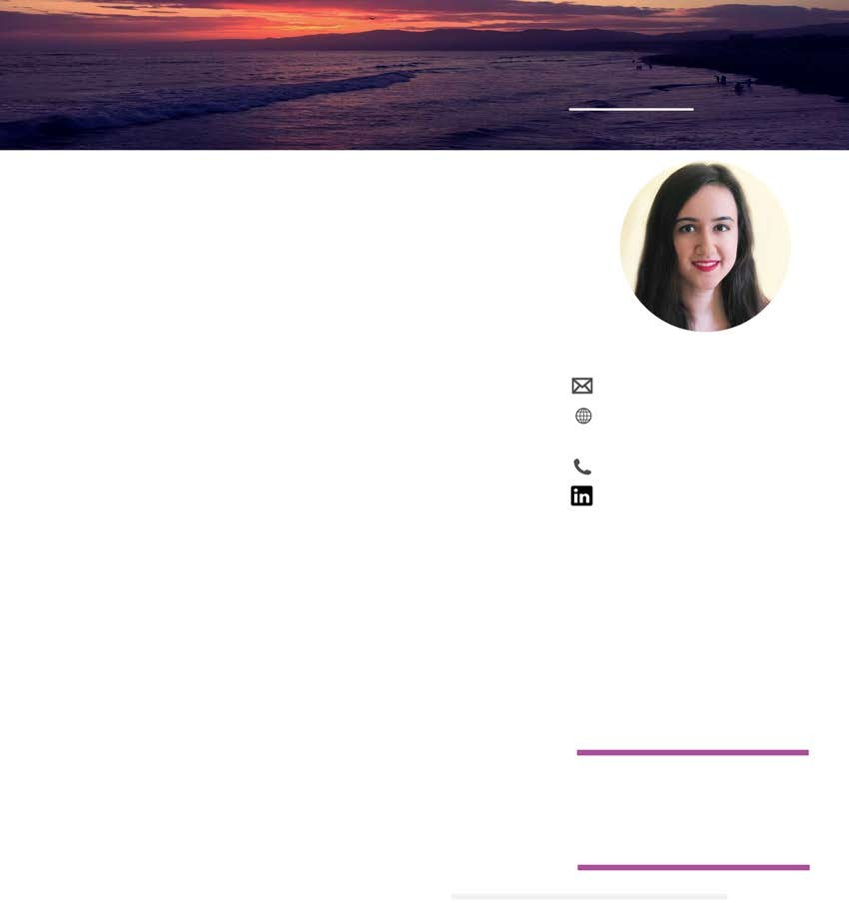

**Symbiosis Centre for Management Studies Media and Consumer Behaviour**

**Markefing Communicafion- Ad, PR & Events Creafivity and Innovafion**

**Markefing Management October 2018 Human Resource Management**

**May 2018 Web Design- Designing Websites and HTML**

**Innovafion Mangement and**

**New Product Development Visual and Audio Communicafion**

**December 2017 Digital Tools I- Adobe Photoshop**

**Search Engine Opfimizafion**

**Search Engine Markefing**

**Content Creafion**

**Ideafion**